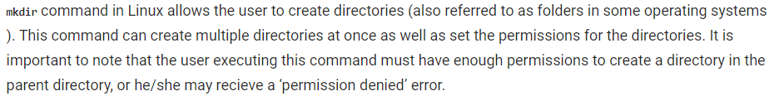

**Syntax:**

**mkdir [options...] [directories ...]**

**-v or --verbose**: It displays a message for every directory created.

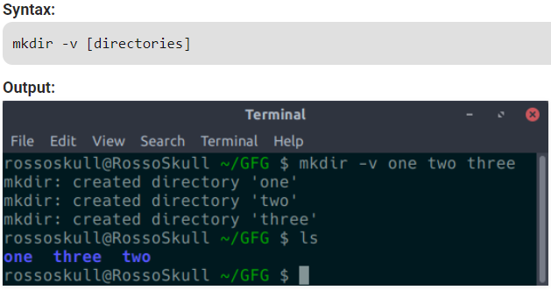

**-p:** A flag which enables the command to create parent directories as necessary. If the directories exist, no error is specified.

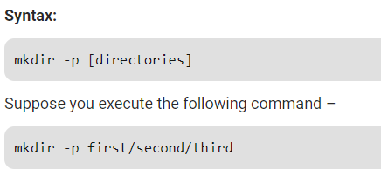

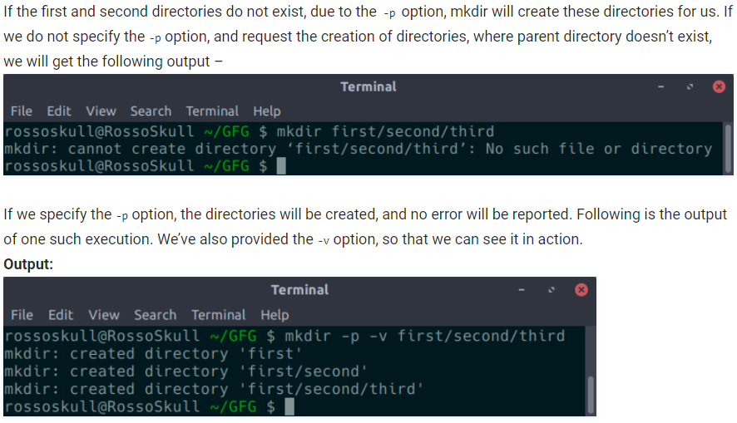

**-m:** This option is used to set the file modes, i.e. permissions, etc. for the created directories. The syntax of the mode is the same as the chmod command.

set its file mode **(-m)** so that all users (a) may read (r), write (w), and execute (x) it.

